2025 IndiGo Operational Crisis: Data Driven Analysis of Delay Spread, Hub Stress & Route Vulnerabilities

1. Introduction
This project analyzes around 67,000 commercial flight records from November 15–December 7 2025 to understand flight delays, operational disruptions, and network level delay propagation within IndiGo’s network. The goal was to explore patterns in delay behavior, compare IndiGo with other airlines, identify crisis period effects, and investigate how delays propagate through major hubs and routes.

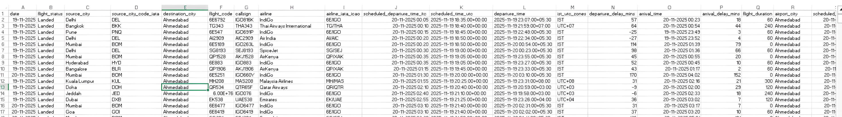
Figure 1 dataset presentation

2. Data Overview
The dataset consists of 67,644 flight observations with detailed timing, delay, route, geographic, and airline identifiers. Extensive preprocessing included:
- Converting >8 datetime fields (several with mixed timezones).
- Fixing corrupted timestamps (e.g., 00:00 vs 24:00 confusion).
- Handling 35% missing delay values.
- Removing unrealistic values (negative delay, duration ≤5 minutes).
- Engineering features: route, extreme delays, crisis labels, hub flags.

3. Methodology
The project used Python, Pandas, NumPy, Matplotlib, Seaborn for data cleaning, EDA, time series analysis, and multi-dimensional comparisons. Methods included:
- Time series aggregation (daily volumes, delays, cancellations).
- Comparative analysis between IndiGo and other airlines.
- KDE distribution analysis across periods.
- Heatmaps for route level delay intensities.
- Network style propagation analysis via hub → route delay transitions.

4. Insights and Findings
Below are the detailed insights derived from each major visualization.

5. Graph Insights and Visualizations

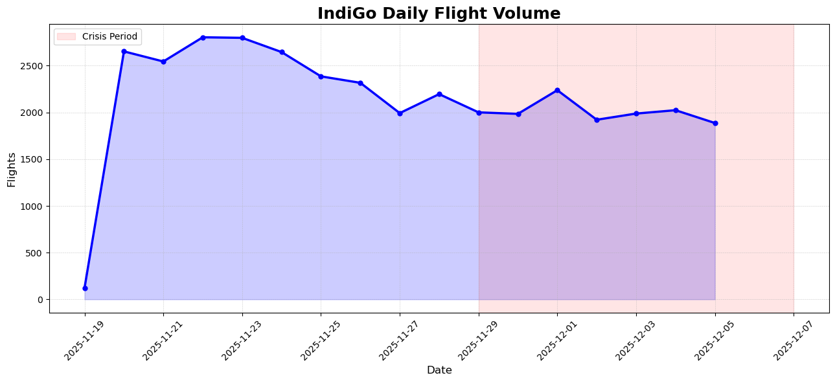
Figure 2 IndiGo Daily Flight Volume
Insight: Flight volume sharply increased from ~120 flights/day to ~2700 flights/day, indicating dataset expansion and the scaling of operations. Minimal volatility suggests steady operations in pre crisis days.
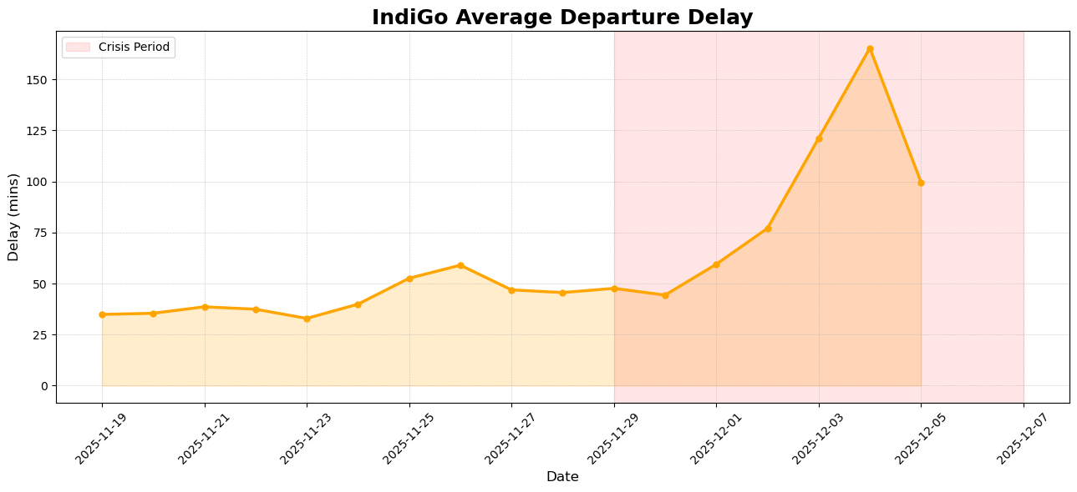
Figure 3: IndiGo Average Departure Delay Over Time
Insight: Pre crisis delays hovered at ~35–40 minutes. Post December 1st (crisis), delays surged to 80–100+ minutes. This confirms a structural shift rather than random fluctuations.
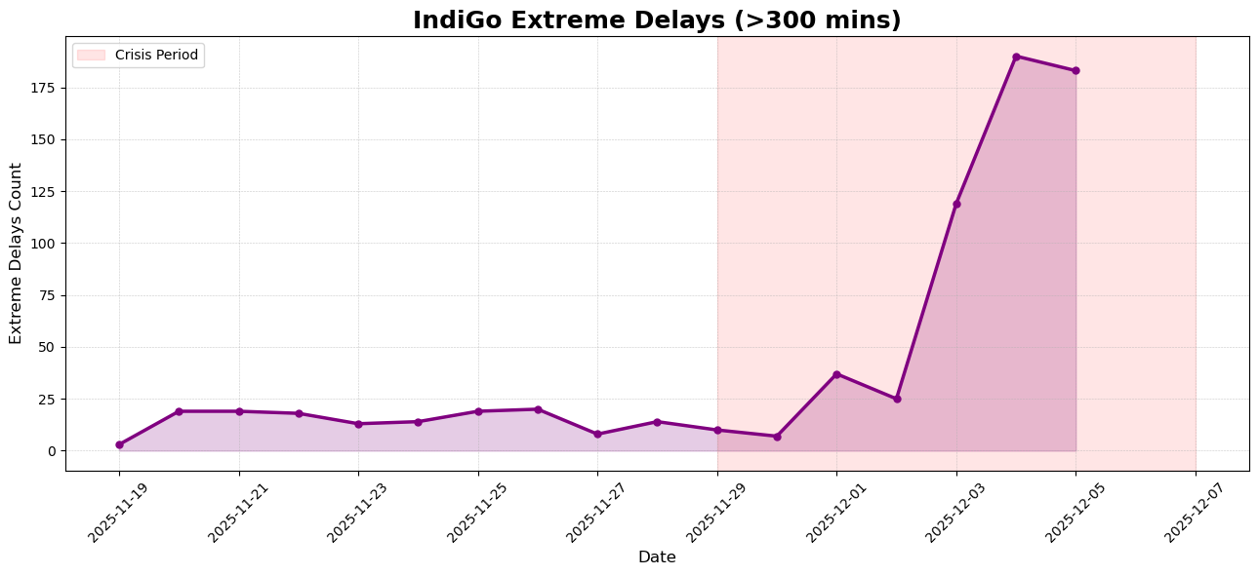
Figure 4: Extreme Departure Delays (>300 mins)
Insight: Extreme delays were rare pre crisis (1–5/day) but spiked massively during the crisis (up to 40/day). This indicates system level breakdown rather than isolated issues.
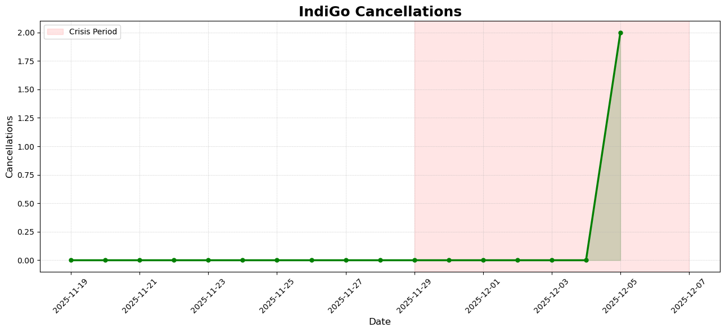
Figure 5: IndiGo Cancellations Over Time
Insight: Cancellations remained nearly zero for IndiGo throughout the dataset. This confirms that delays, not cancellations, were the primary driver of operational challenges.

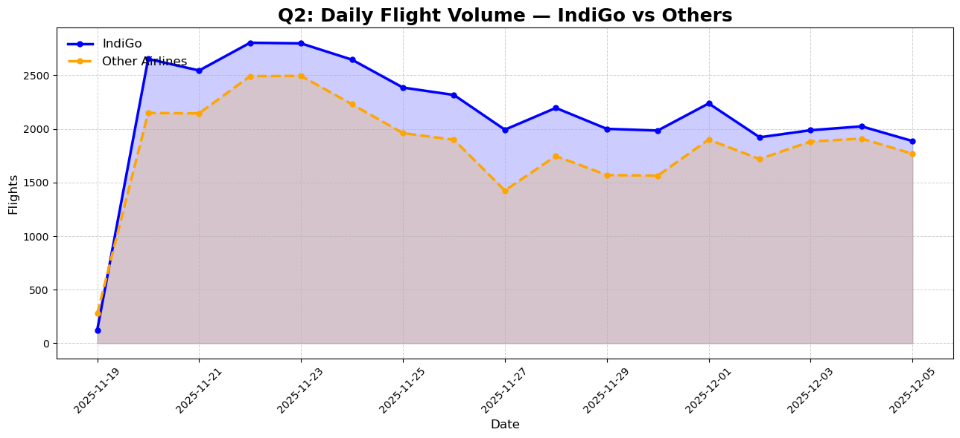
Figure 6: IndiGo vs Other Airlines – Flight Volume
Insight: Other airlines show a parallel scale up but remain consistently lower than IndiGo. The similarity in trend suggests industry wide seasonal or operational shifts.
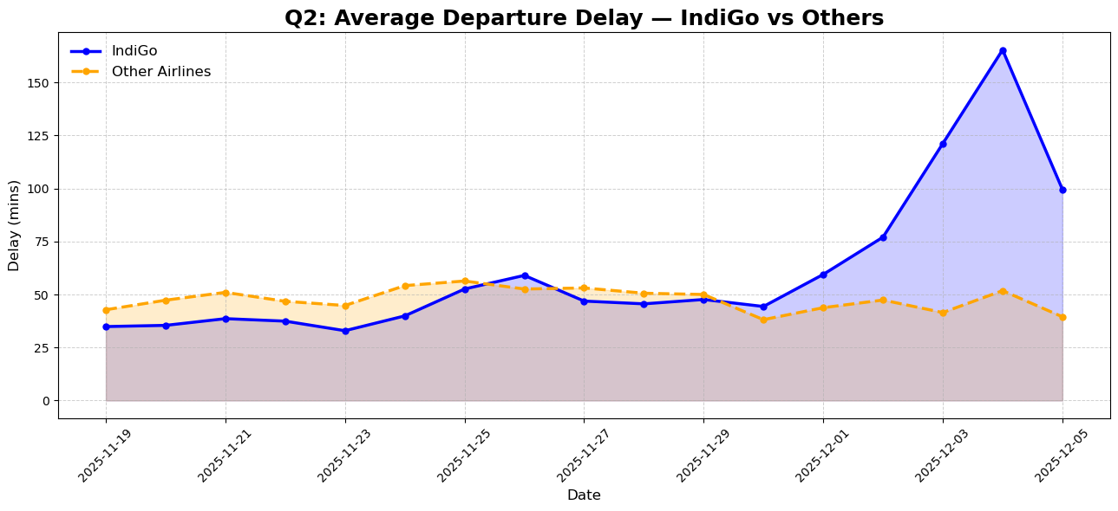
Figure 7: IndiGo vs Others – Average Delay Comparison
Insight: Other airlines consistently experienced higher delays than IndiGo (10–20 mins difference on average). However, during the crisis, both groups spiked, confirming systemic factors affecting all carriers.

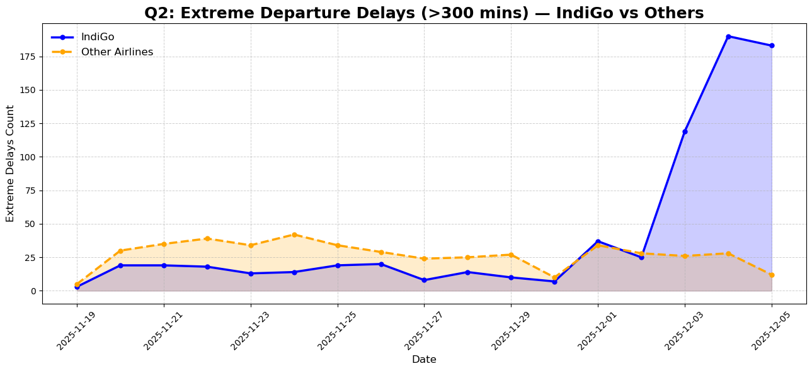
Figure 8: IndiGo vs Others – Extreme Delay Comparison
Insight: Other airlines had more extreme delays than IndiGo, but both groups saw a surge during crisis days. This reinforces the idea of shared external disruptions.
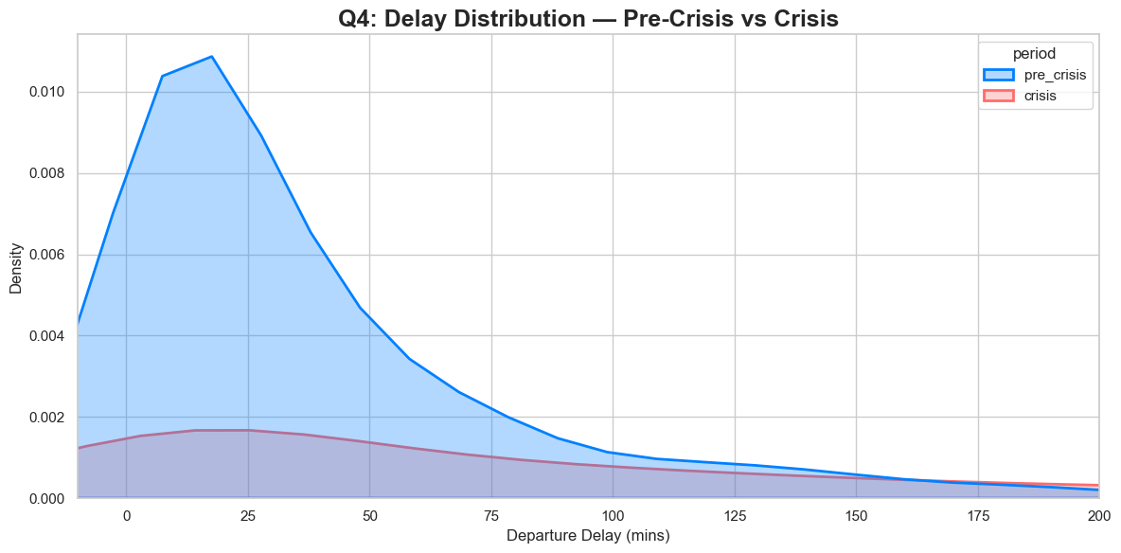
Figure 9: Delay Distribution (Pre Crisis vs Crisis)
Insight: Pre crisis delays follow a compact distribution centered around 15–30 minutes. Crisis delays show a long right tail, indicating many high delay events. This confirms heavy operational strain.

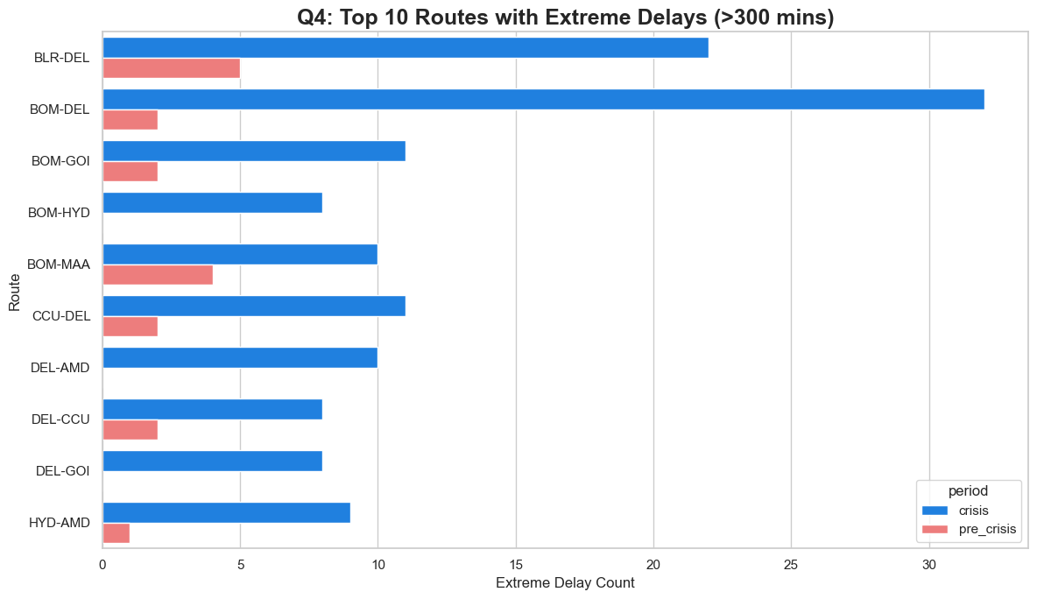
Figure 10: Top Disrupted Routes
Insight: The worst hit crisis routes (BOM DEL, BLR DEL, DEL CCU) also align with the busiest corridors. High frequency + hub congestion = maximum delay propagation.
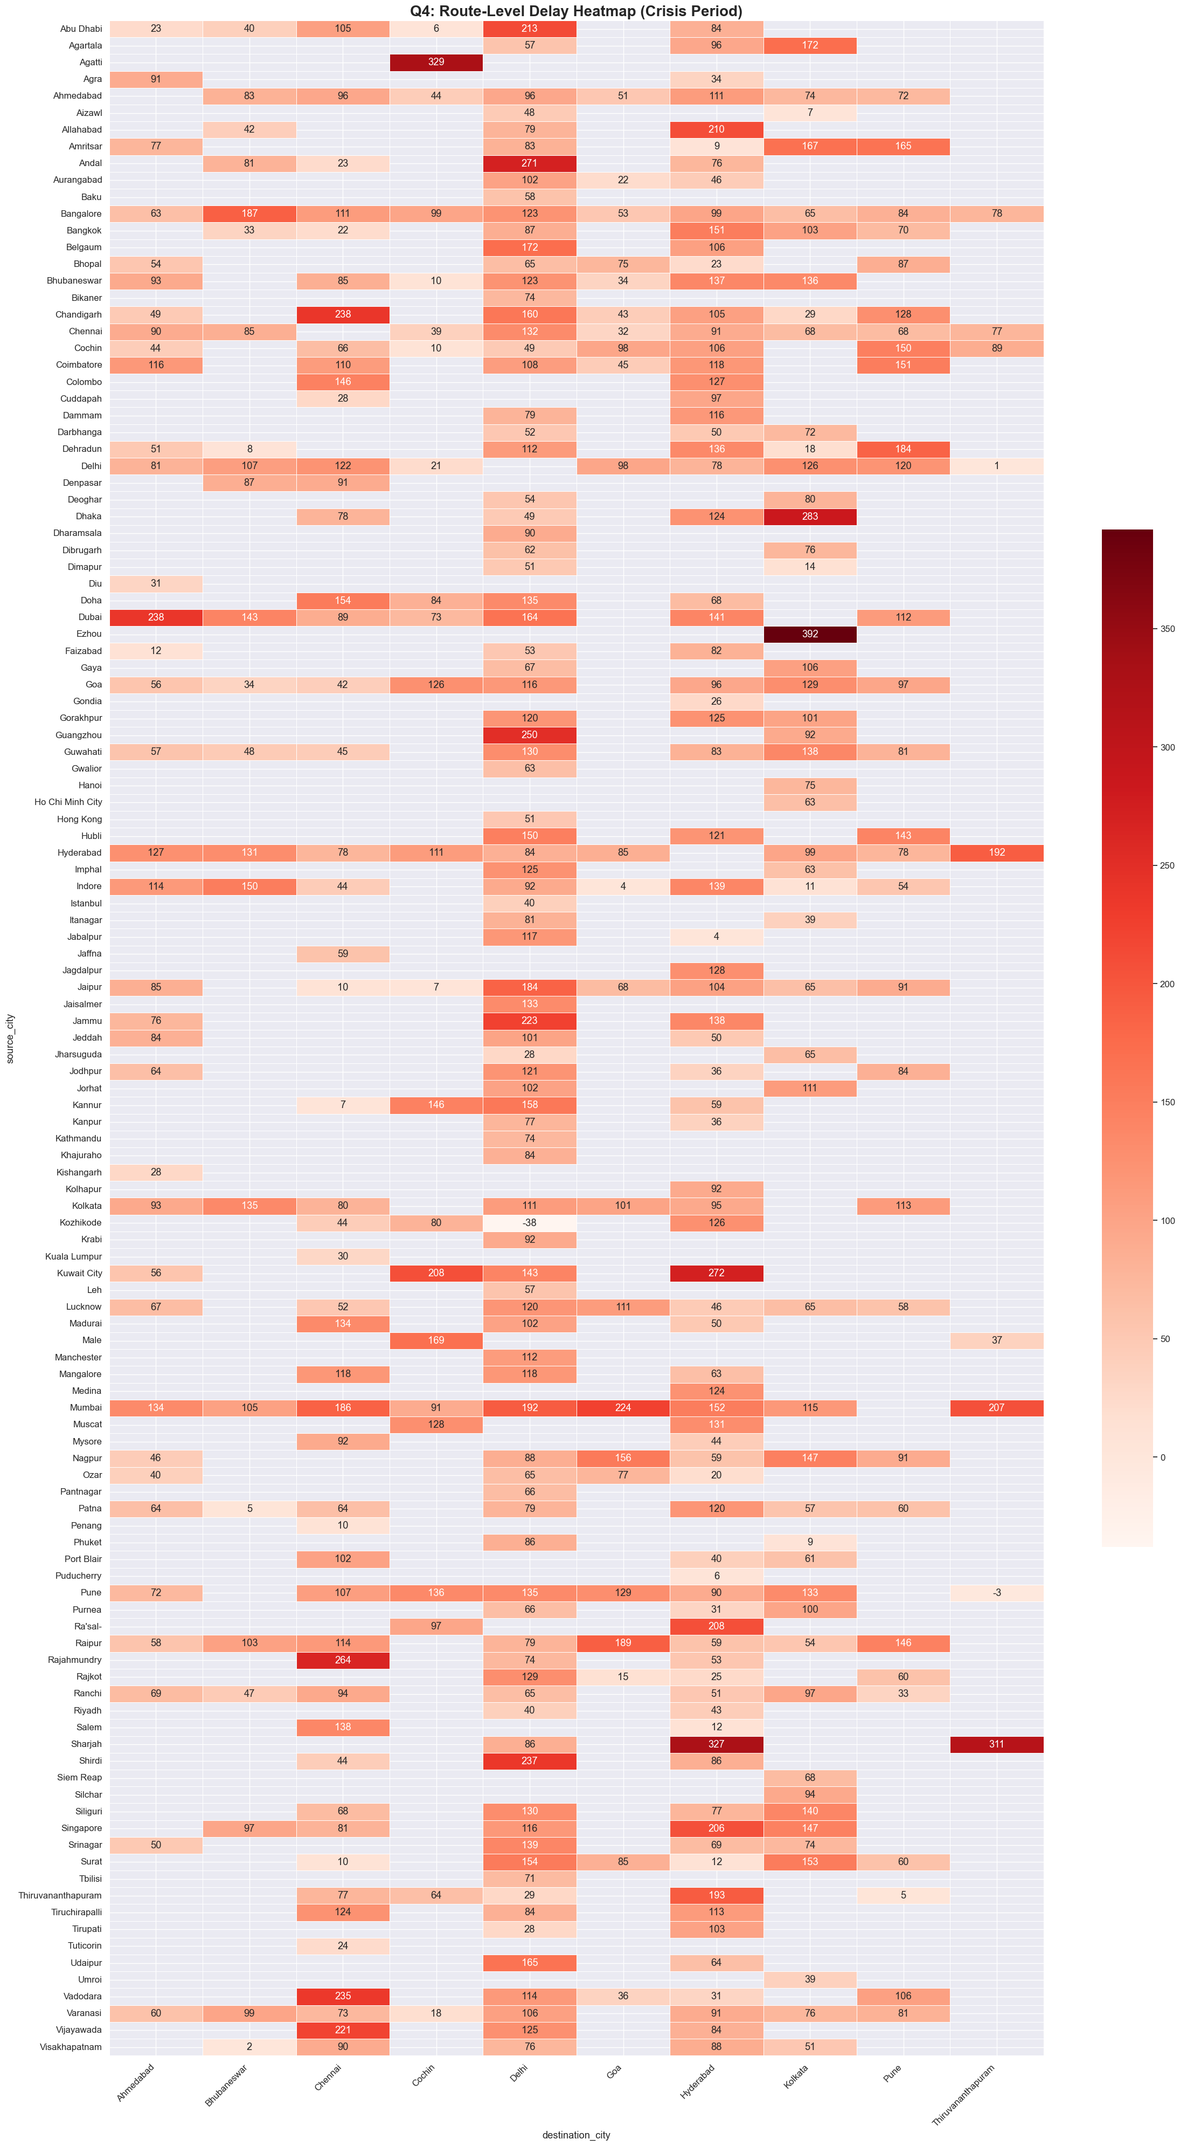
Figure 11: Crisis Heatmap of Route Delays
Insight: The heatmap shows clear route specific and asymmetric delay patterns, with some directions experiencing far higher delays than their reverse routes. Major high delay corridors include BOM→DEL, DEL→CCU, BLR→DEL, BOM→HYD, and PNQ→DEL, indicating concentrated congestion on routes feeding into major hubs like Delhi, Kolkata, and Hyderabad during the crisis period.

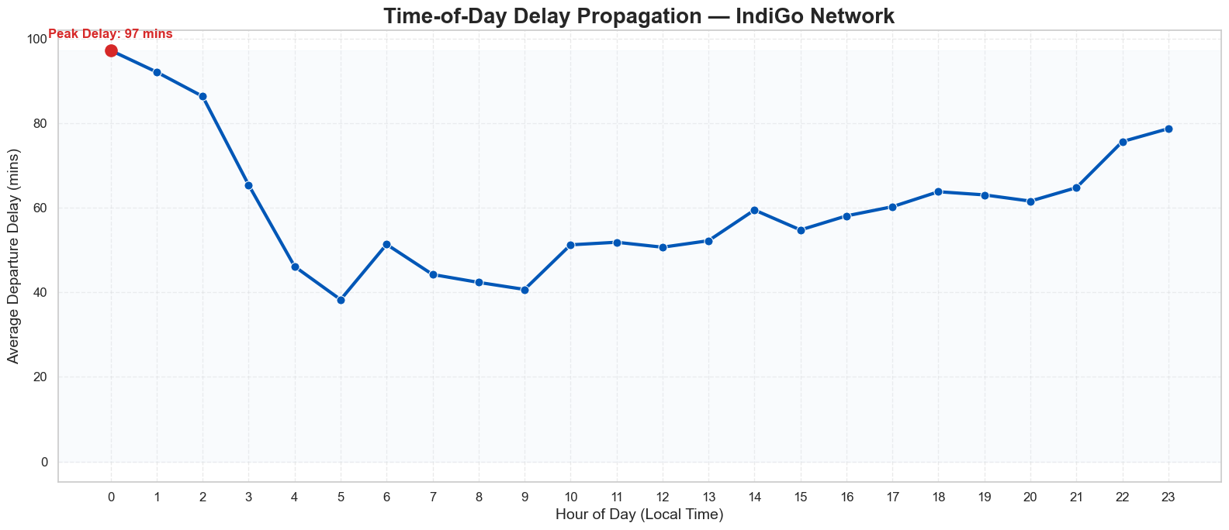
Figure 12: Time of Day Delay Propagation

Insight: Delays peak right at the start of the day (around midnight–2 AM) and then drop quickly through the early morning. Through the afternoon, delays stay fairly stable, before gradually rising again in the evening—though they never reach the early morning peak. This shows that the biggest disruption actually starts overnight, not from afternoon cascading effects.

6. Challenges and Limitations
- Heavy missing data (35% missing delays) required careful filtering.
- Mixed timezones caused parsing errors and required multi step fixes.
- Cannot analyze aircraft level propagation due to missing tail number data.
- No weather/ATC data prevents direct attribution of external causes.

7. Conclusion
The analysis demonstrates strong evidence of delay escalation caused by:
- Hub congestion (Mumbai, Delhi, Bangalore).
- Early morning delays propagating into network wide disruptions.
- Crisis period conditions amplifying delay magnitudes.

IndiGo performed better than other airlines but was still significantly affected during crisis days.

8. Recommendations
- Stabilize Early Morning Operations Add buffer time and prioritize on time first wave departures to prevent full day delay cascades.
- Focus on Hub Resilience Improve congestion management at Mumbai, Delhi, and Bangalore through better staffing, gate planning, and real time monitoring.
- Optimize Aircraft & Crew Rotation Reduce long dependency chains and introduce standby aircraft/crew on high risk routes.
- Strengthen Crisis Management Build scalable contingency schedules and improve coordination with ATC and ground operations during demand spikes.
- Use Predictive Delay Analytics Implement machine learning models to forecast delays and take preventive action.
- Improve High Risk Routes Add operational buffers and assign more reliable aircraft on critical corridors like BOM–DEL and DEL–CCU.
- Enhance Passenger Communication Offer clear, real time delay explanations and smarter rebooking options.
- Integrate External Data Use weather, ATC, and runway data to proactively adjust schedules and resources.

9. References
Dataset: Flight dataset scraped via flightera.net (15 Nov 07 Dec 2025) (67,644 rows)

